**React App for E-Commerce Website**

Contents

Document Description 2

Change Log 2

User Stories 3

Style Guide 9

Code guidelines 15

HTML 15

CSS 15

Fonts 15

Colour Palette 15

# Document Description

This document describes the business requirements that need to be implemented for completing a portfolio page for describing oneself.

# Change Log

|  |  |  |  |  |
| --- | --- | --- | --- | --- |
| S. No. | Update | Version | Updated By | Updated On |
| 1. | Created the document for functional specifications for the application | 1.0 | Vaibhav Vashishtha | 12th Sept’20 |
| 2 | Updated the document as per the react application created | 1.1 | Kannan Azhagappa | 16th Nov’20 |

# User Stories

|  |  |  |  |
| --- | --- | --- | --- |
| User Story ID | As a (user) | I want to (task) | So that I can (result) |
| 1 | As a person who visits the E-Commerce Website | Should be able to see details about the App in Home Page | So that I can know more about the App |
| 2 | As a person who visits the E-Commerce Website | Should be able to see the Sign in Page | So that the User can login |
| 3 | As a person who visits the E-Commerce Website | Should be able to see the Sign Up Page | So that the User can sign up for the App |
| 4 | As a person who visits the E-Commerce Website | Should be able to see error validation messages for both Sign Up and Sign In Pages | So that the user is aware of the errors |
| 5 | As a person who visits the E-Commerce Website | Should be able to see their profile once successfully login | So that the user is aware of their profile |
| 6 | As a person who visits the E-Commerce Website | Should be able to see the Product Catalogue | So that the user is aware of the products |
| 7 | As a person who visits the E-Commerce Website | Should be able to see the product details in high level | So that the user understands about the product |
| 8 | As a person who visits the E-Commerce Website | Should be able to option to add to cart | So that the user can choose items to add to cart |
| 9 | As a person who visits the E-Commerce Website | Should be able to see their cart | So that the user knows what they have added to their cart |
| 10 | As a person who visits the E-Commerce Website | Should be able to see their price total for the products selected | So that the user sees the amount they need to pay |
| 11 | As a person who visits the E-Commerce Website | Should be able to remove cart items | So that the user can unselect the products not needed any more |
| 12 | As a person who visits the E-Commerce Website | Should be able to sign out from the App | So that the user can safely come out from the App |
| 13 | As a person who visits the E-Commerce Website | Should be able to see product and cart page only after login in | So that the user is authenticated before enjoying the app functions |
| 14 | As a person who visits the E-Commerce Website | Should be able to upload images and see image gallery | So that the user has a real application feeling |

Layout of the App

This section defines the standards for the look and feel of the page

Home Page:

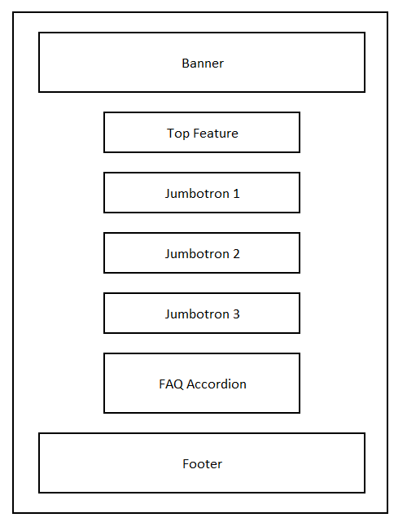

Sign Up & Sign In Pages:

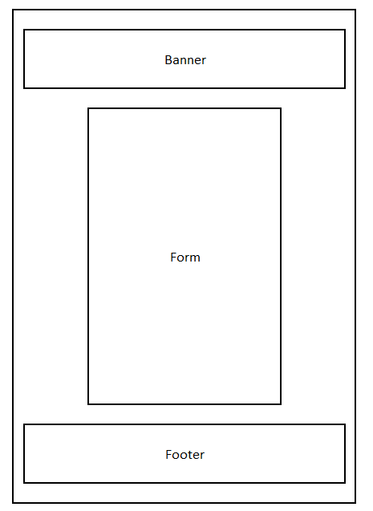

Profile Page:

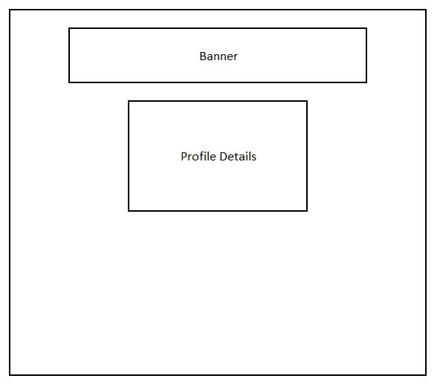

Browse Page:

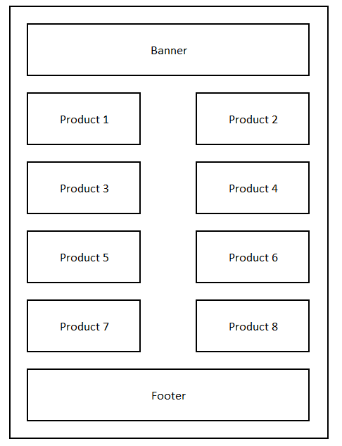

Check Out Page:

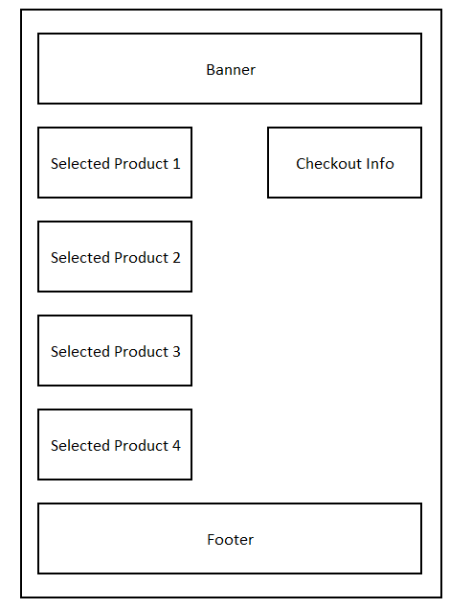

All this design are responsive to size of the screen and it will stack up accordingly.

# Style Guide

This guide defines the standards that will be followed while developing and styling the web page using CSS.

* Generic style for the complete page (For font family mainly)
* Generic background style for the body of the page
* Generic style for any list and anchor links in the page
* Generic style for the name and its container
* Generic style for the description
* Generic style for the image
* Generic style for the banner
* Styled components
* Some Components with Raw CSS Stylings
* Generic style for Buttons
* Material UI and Image Icons for Banners, Loading, User Profiles and Search Options
* Media Queries to make the website responsive

Outlook of the Application:





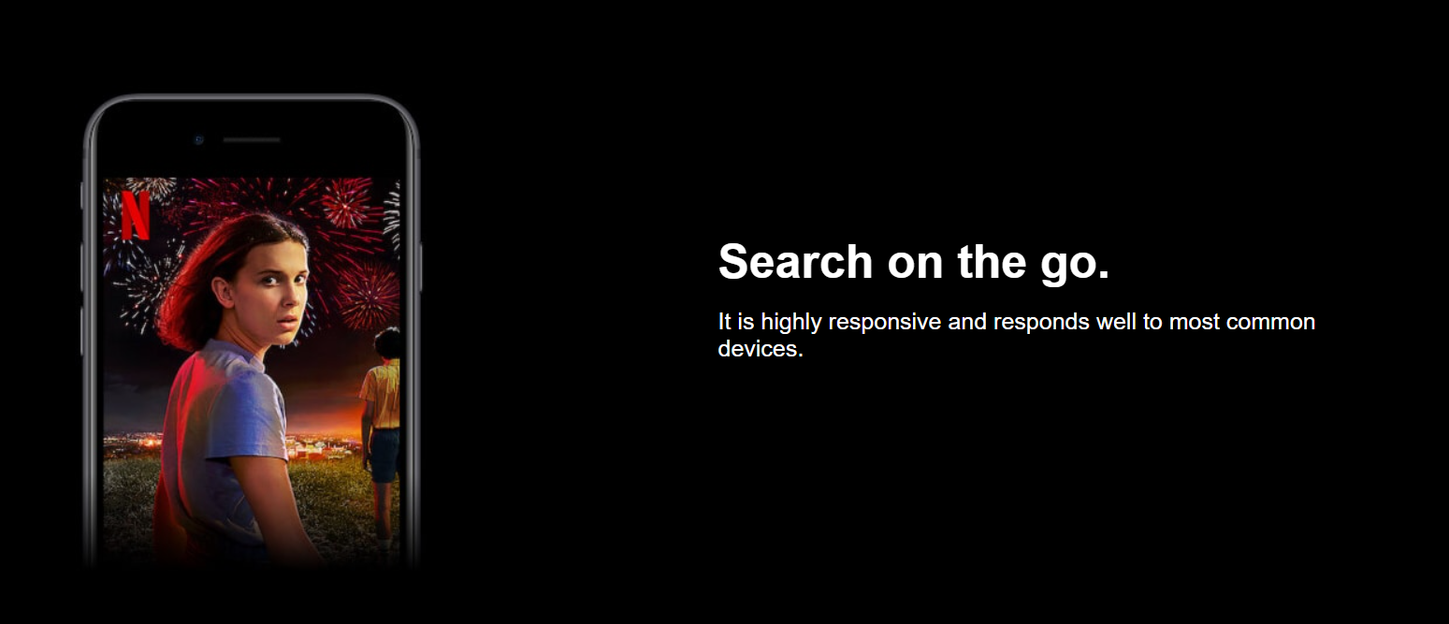

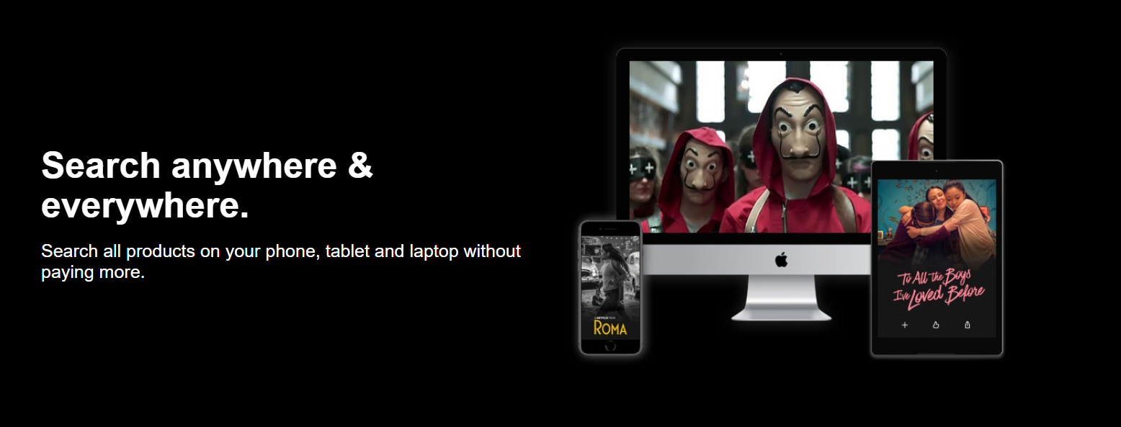

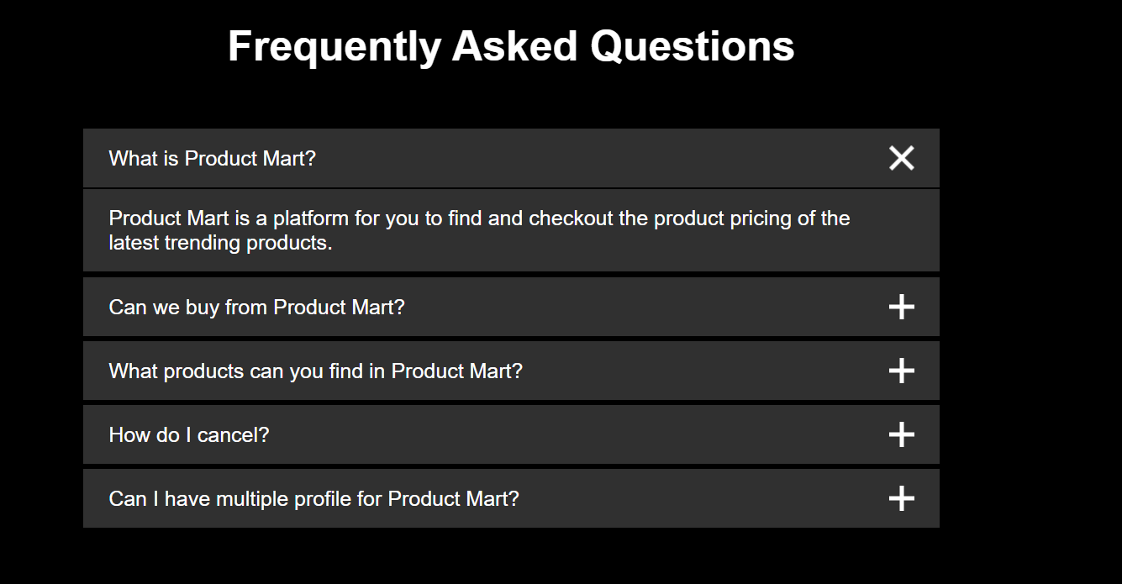

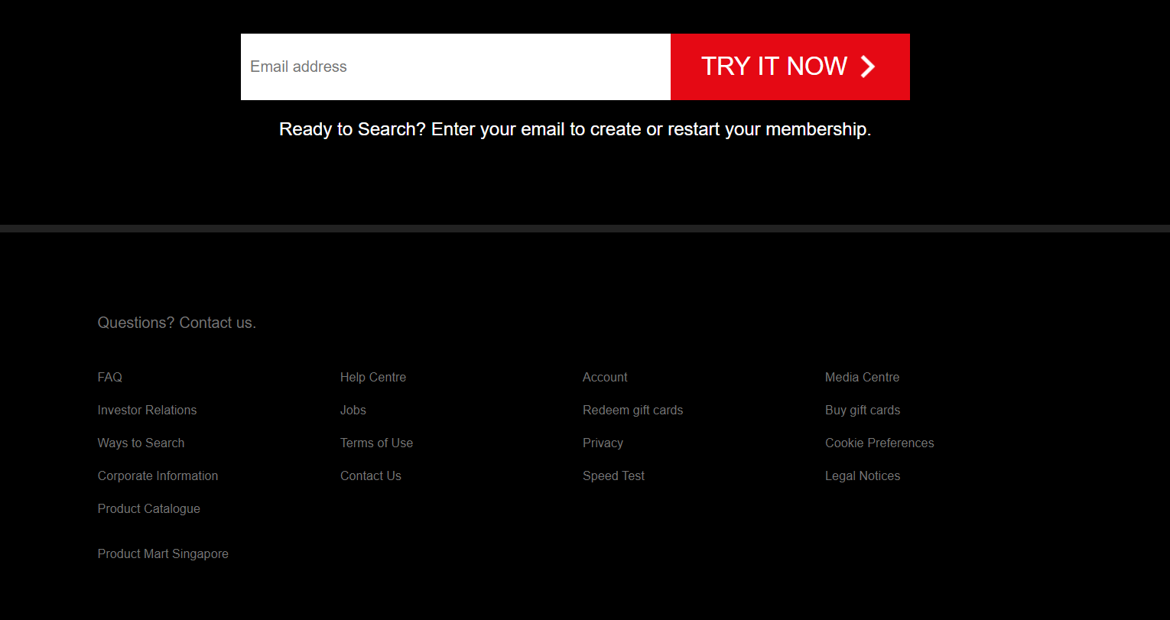

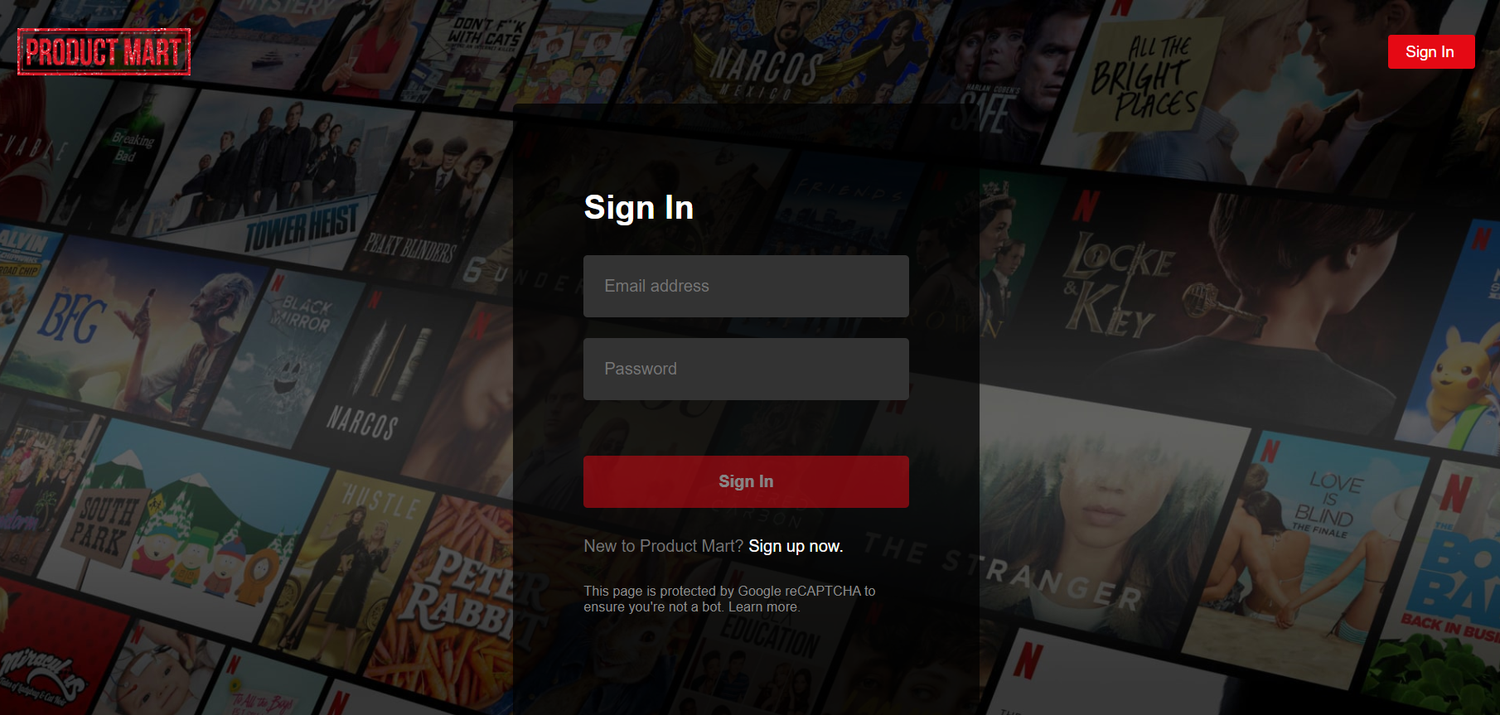

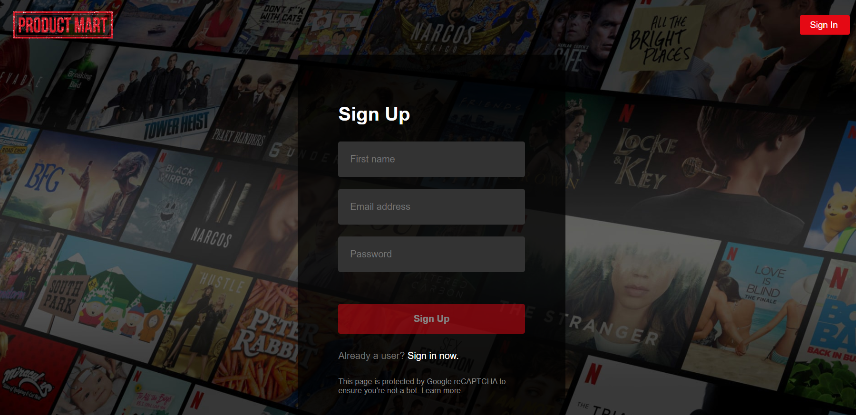



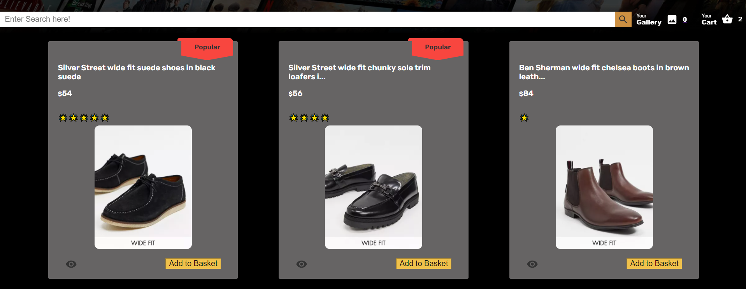

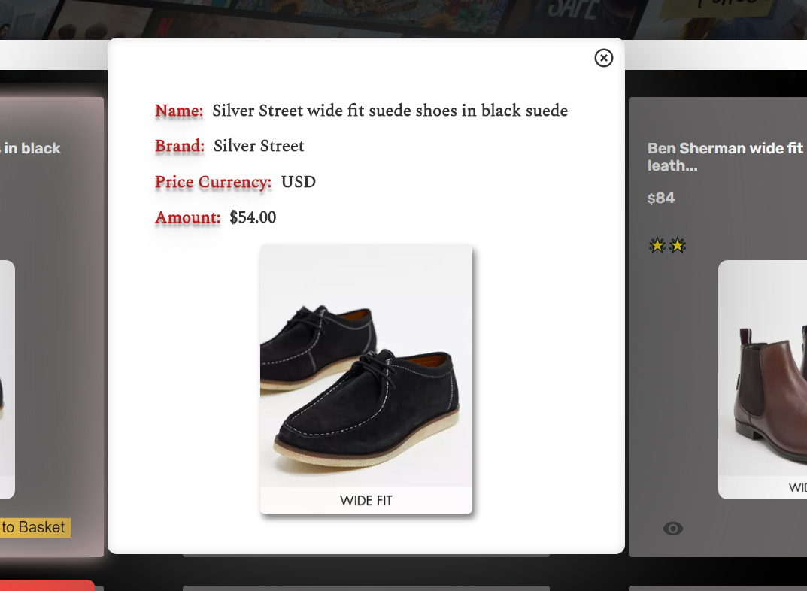

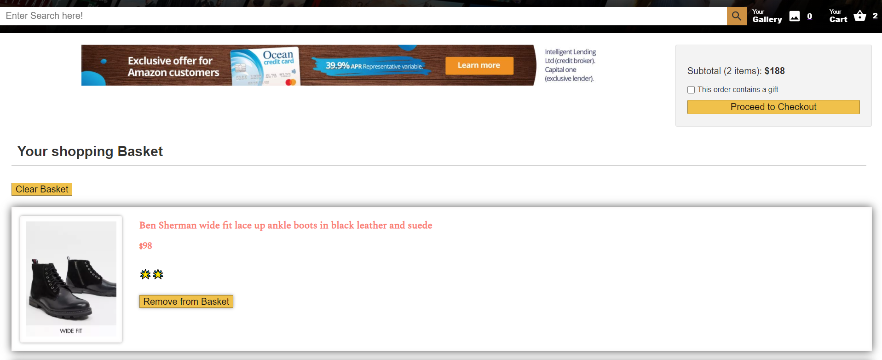

# Code guidelines

This section defines the coding standards that will be followed during the development of the web page

### HTML

* Always Doctype Header
* Use a new line for all elements
* Wrap long lines
* For attribute values use double quotes and no single quotes

### CSS

* Use meaningful selector names
* Try and reuse classes
* Try and avoid type selectors for qualification
* Do not use units for 0 values
* Avoid hacks

# Fonts

Few variations of fonts for this entire App but with variation in the sizes as per the elements. The fonts used are Helvetica Neue, Helvetica, Arial, Spectral, Rubik, Noto Serif and sans-serif.

# Colour Palette

* Main colours
  + Red (few shades such as salmon, firebrick and etc)
  + White (few shades)
  + Black (few shades)
  + Yellow
  + Grey
  + Orange